**Monitoring and logging - rules writing**

-> Launch an EC2 instance

-> Install Node Exporter, Prometheus, and Grafana  
-> [https://jhooq.com/prometheous-grafan-setup/#3-installing-the-grafana](https://jhooq.com/prometheous-grafan-setup/" \l "3-installing-the-grafana)

Node Exporter

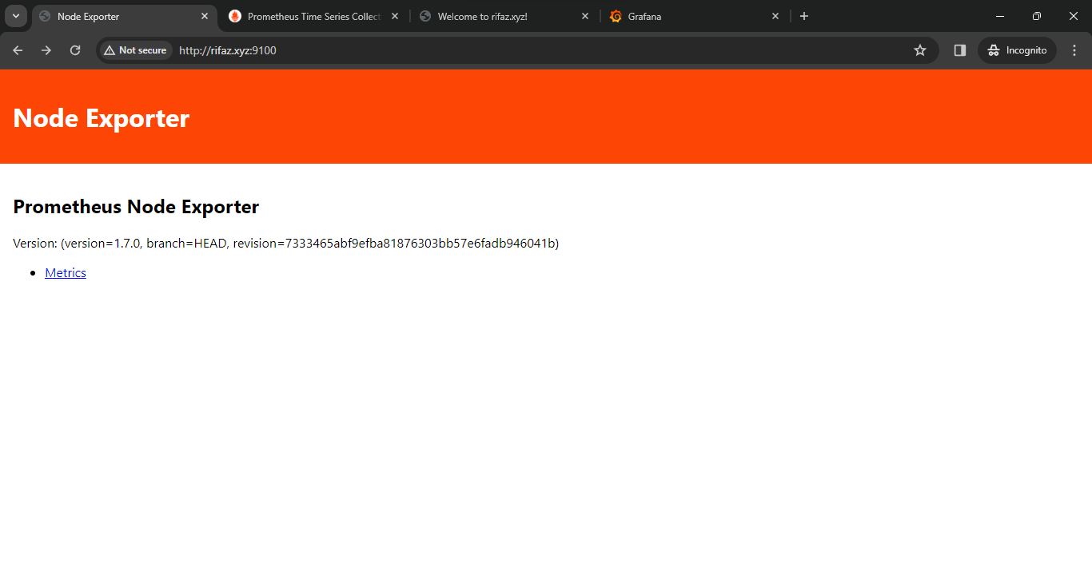

Prometheus

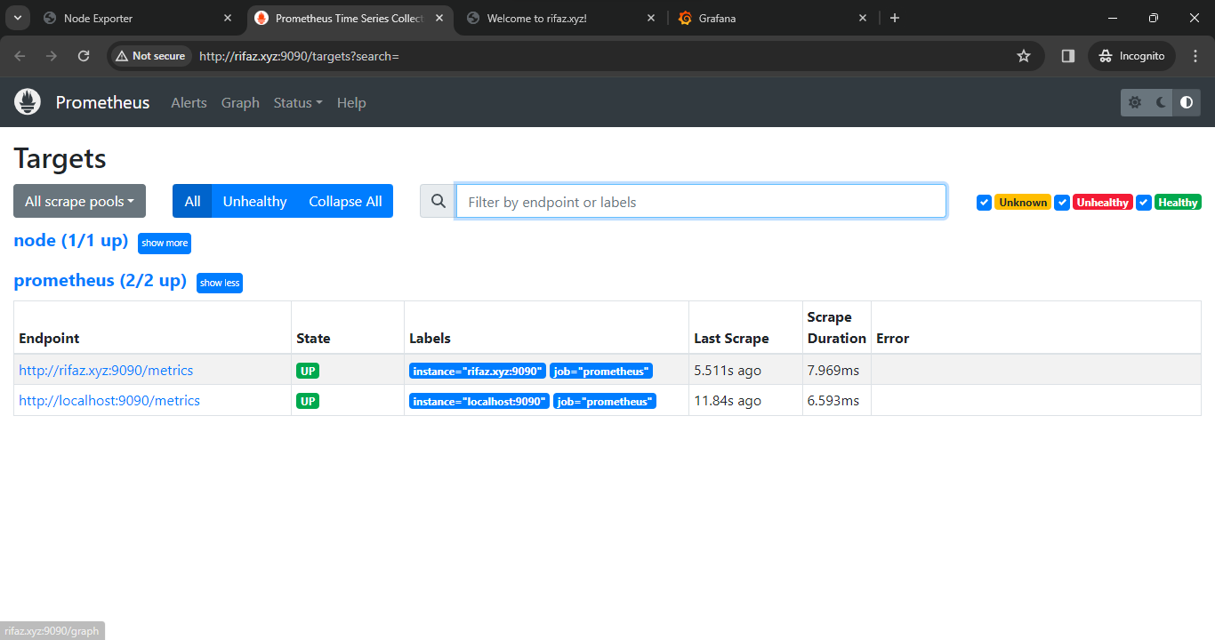

Grafana

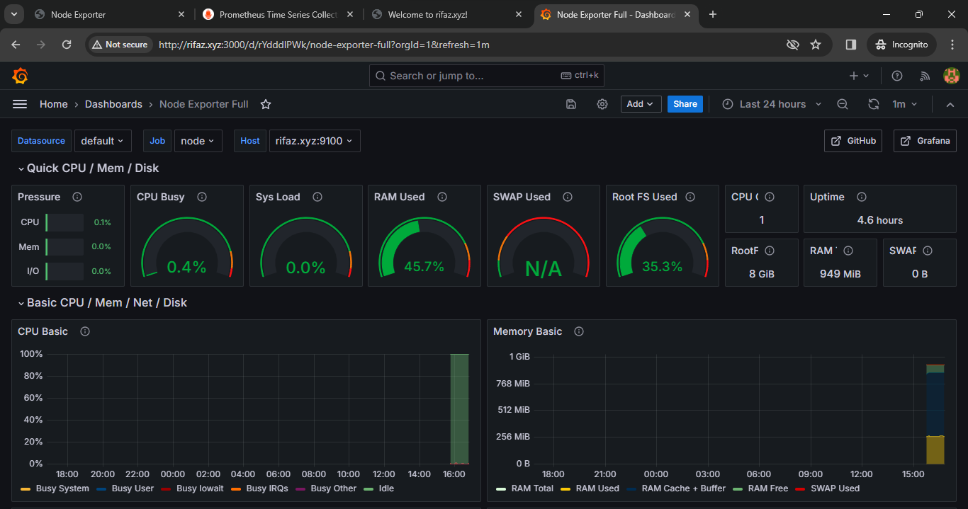

Setup email integration for Alert Notification inside Grafana.

-> <https://youtu.be/YUabB_7H710?si=vFoEom_0O0-Vx1c5>

-> <https://youtu.be/nW5AuEtSqVc?si=hnlDcaUMeeQ2Y63V>

-> https://youtu.be/nW5AuEtSqVc?si=Z4rHdVnX0uVf1NLN

-> <https://youtu.be/U69YYWV7BW0?si=6jS8nm22Z25adEfX>

-> <https://youtu.be/g0gBKtcDOYc?si=kcs72wnejUPplbh3>

-> Edit the grafana.ini file

      sudo vi /etc/grafana/grafana.ini

-> Inside grafana.ini search for SMTP and make some changes and save it.

https://app.brevo.com/settings/keys/smtp

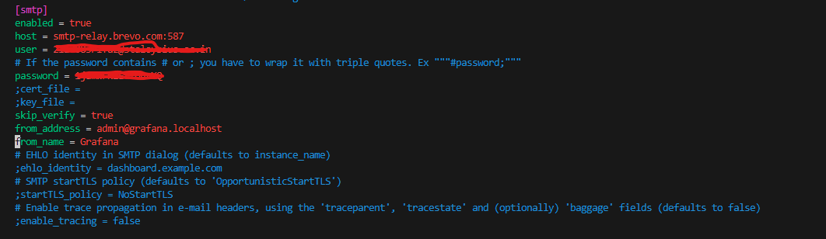

-> Restart grafana

-> Inorder to create Alert Notification go to **Alerting** Option Inside Grafana.

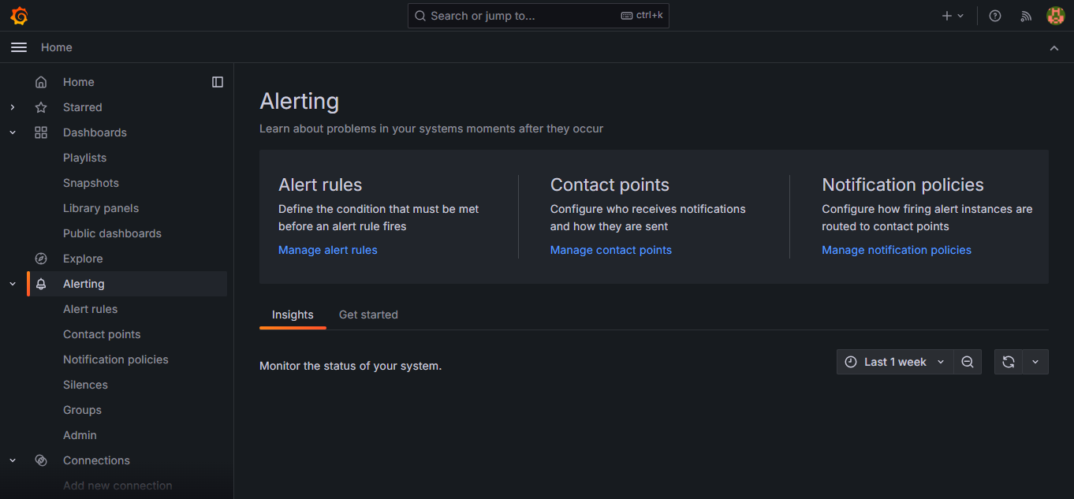

-> Then first create the Alert Rules for that go to **Manage alert rules** and then click on **New Alert Rule**. Inside that create a alert rule.

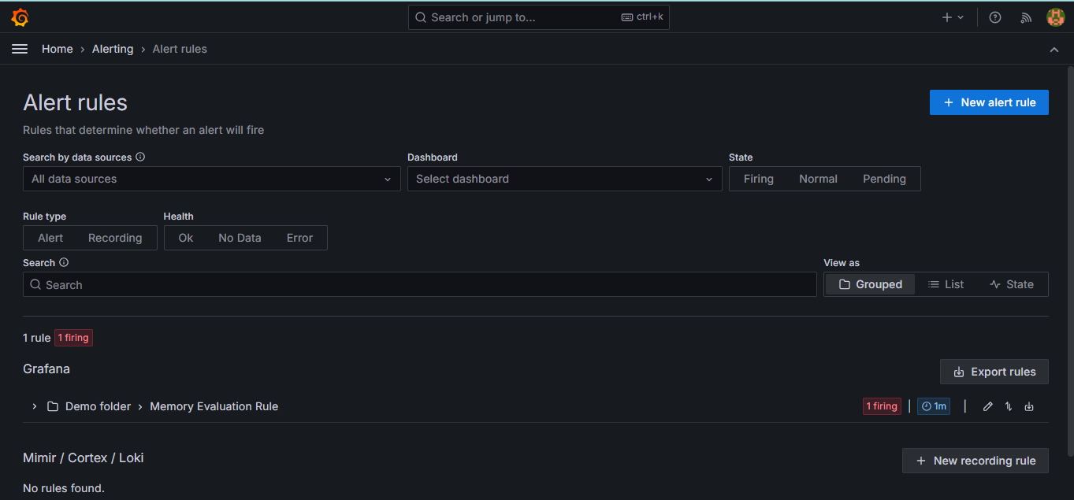

-> Edit the information for alert Rule.

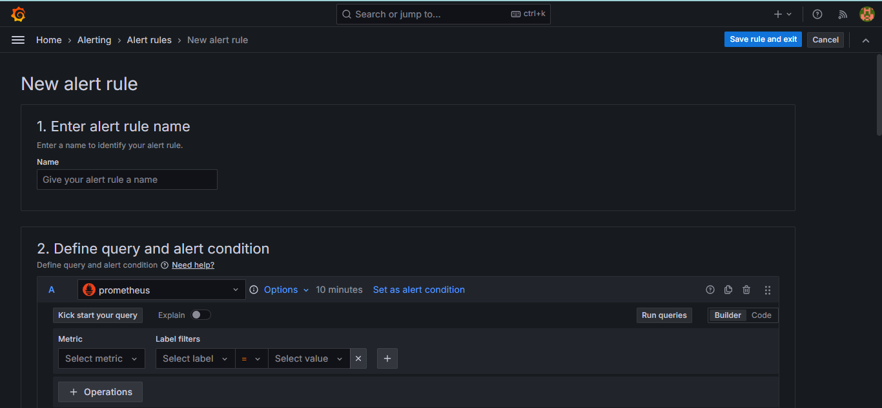

-> Once Edited the Alert Rule then save and exit from it.

-> Next go to Contact Points where you can set to whom you want to send the Notification alert.



-> Then click on **Add cotact point** and set the contact details and then save and exit.

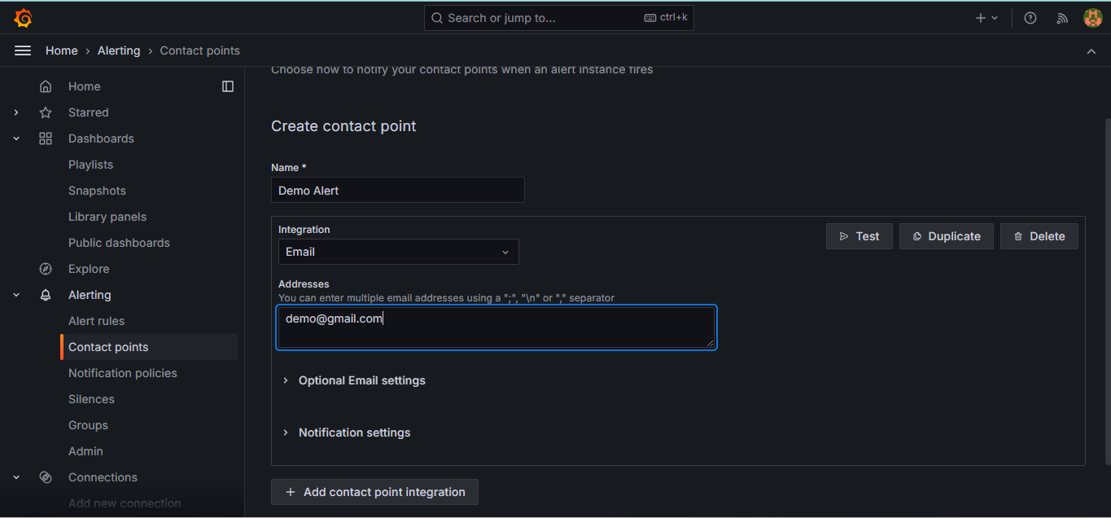

-> Then to send notification you can edit **Notification policies**



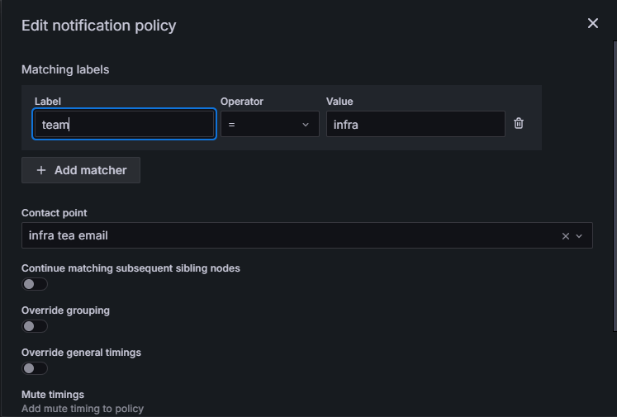

-> Edit notification policy and save it

-> Once all this is done you will receive a notification alert to your email whenever there is a conflict in dashboard.

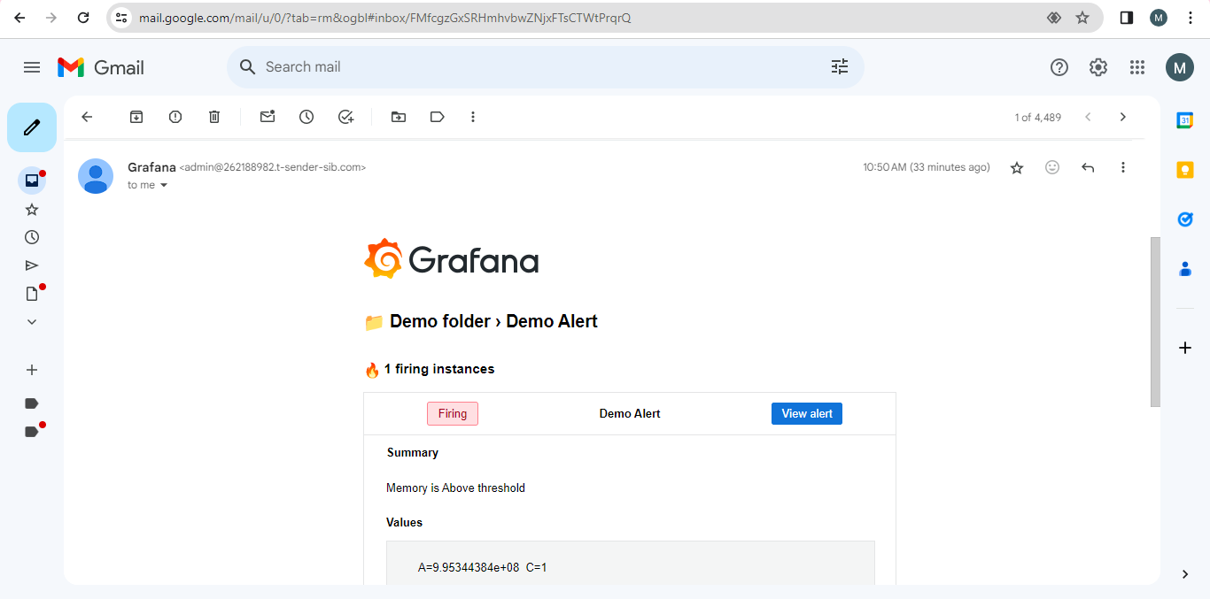

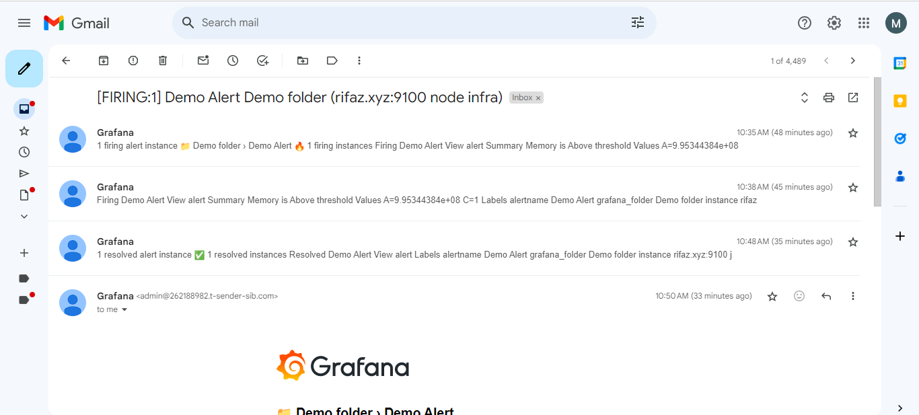

http://rifaz.xyz:3000/d/ddgf58auv60owb/server-dashboard?orgId=1&from=1711097796823&to=1711099025788